**ACS 2913 – SOFTWARE REQUIREMENTS ANALYSIS AND DESIGN**

ASSIGNMENT 3

*DAMILARE ALESHINLOYE: 3099949*

*AVISHEK RAJ: 3107155*

*ANUOLUWAPO OYAFUNKE: 3092896*

1.

|  |  |
| --- | --- |
| **Use Case Name:** | Add to Cart |
| **Scenario:** | Add items to the shopping cart |
| **Triggering Event:** | Customer selects an item and clicks the add to cart button |
| **Brief description:** | Inventory system checks if the item is available, the items are then added to the cart for future checkout |
| **Actors:** | Customer |
| **Related use cases:** | Check out cart |
| **Stakeholders:** | Sales, warehouse employees, customer |
| **Preconditions:** | A customer must login.  Item should be in stock. |
| **Postconditions:** | Order is created and a rough invoice generated.  Cart displays the items and prices before taxes individually.  Customer can check out at any time in between ordering. |
| **Flow of Activities:** | |  |  | | --- | --- | | **Actor** | **System** | | 1. Clicks on an item and click add to cart. | 1.1 Checks if there is stock available. If yes, adds the item to shipping cart. | | 1. Clicks on the cart icon. | 2.1 System retrieves added items and displays the invoice. | | 1. Proceeds with payments. | 3.1 System empties the cart. | |
| **Exception Conditions:** | 1.1 Stock is not available. Generate an order for warehouse and respond timely with updated levels.  2.1 No items to display. Ask the customer to add to cart to see a rough quotation. |

|  |  |
| --- | --- |
| Use case name : | Checkout cart |
| Scenario : | Checking out of items inside cart |
| Triggering event : | Customer wants to purchase items in cart |
| Brief description : | Customer checks out cart by entering required credit card information and shipping information and placing order |
| Actors : | Customer |
| Related use cases : | Might be invoked by create customer account use case |
| Stakeholders : | Customer, Marketing, sales |
| Preconditions : | Product must be in stock  Customer information must be complete |
| Postconditions : | Customer information must be validated  Credit/debit card information must be authorized  Customer address must be saved and validated |
| Flow of activities : | |  |  | | --- | --- | | Actor | System | | 1. Customer has picked out all items and desires to checkout 2. Customer fills in details 3. Customer fills in payment info | 1.1 System displays billing information  1.2 System returns customer information form  2.1 System checks information filled in  2.2 System returns billing total  3.1 System authorises Payment method  3.2 Products are ordered | |
| Exception conditions : | 1.1 Customer shipping information is invalid  1.2 Credit/ debit information isn't valid  1.3 Product inside cart is out of stock or unavailable |

|  |  |
| --- | --- |
| **Use Case Name:** | Ship out product |
| **Scenario:** | Ship items that have been paid. |
| **Triggering Event:** | Shipping receives notification to deliver items. |
| **Brief description:** | Shipping retrieves order details, looks for individual items, records which items are not available and sends the shipments. |
| **Actors:** | Sales, Warehouse manager, Marketing, Shipping companies |
| **Related use cases:** | None |
| **Stakeholders:** | Sales, warehouse employees, Marketing, Shipping companies |
| **Preconditions:** | Customers and address must exist.  Order must exist.  Order items must exist.. |
| **Postconditions:** | Shipment is created and assigned to shippers.  Shipped items are updated as shipped.  Shipping label is verified. |
| **Flow of Activities:** | |  |  | | --- | --- | | **Actor** | **System** | | 1. Shipping requests sale and sale items information. | 1.1 Looks up the sales item description and retrieves customer address and other details. | | 1. Shipping assigns shipper | 2.1 System creates shipments and assigns it to a shipper. | | 1. Shipped items are recorded as shipped. | 3.1 System updates the sale item as shipped. | | 1. Shipping requests shipping label recording shipment size and weight. | 4.1 System produces the label.  4.2 System records shipment cost. | |
| **Exception Conditions:** | 2.1 Shipper is not available to this location, so select another.  3.1 If item is damaged, get new item and inform inventory systems.  4.1 Labels don’t print correctly, manually record the details. |

|  |  |
| --- | --- |
| **Use case name :** | Check product availability |
| **Scenario:** | The availability of a particular product seeks to be checked |
| **Triggering event:** | Warehouse personnel wants to check availability of a product |
| **Brief description :** | Warehouse personnel wants to check for availability of product by going through stock and checking |
| **Actors:** | Warehouse personnel |
| **Related use case:** | none |
| **Stakeholders:** | Sales, Marketing, Warehouse manager |
| **Preconditions:** | Product must be in the system  Product must have been in stock at some point in time |
| **Postcondition:** | If product is in stock appropriate person must be informed  If product not in stock then appropriate personnel must be notified and item be restocked |
| **Flow of activities:** | |  |  | | --- | --- | | Actor | System | | 1. Warehouse personnel seeks to find product availability by entering product information 2. Warehouse personnel informs appropriate person on product availability | 1.1 System reads product id  1.2 System finds product and returns availability  2.1 Updates information about product | |
| **Exception conditions:** | 1.1 Wrong product id is entered |

|  |  |
| --- | --- |
| **Use Case Name:** | Update Profile Information |
| **Scenario:** | Update customer account information |
| **Triggering Event:** | Customer with an account wants to change or update some information on account profile. |
| **Brief description:** | Customer online with an account updates information on account like name, date of birth, shipping addresses, credit card information, and so on. |
| **Actors:** | Customer |
| **Related use cases:** | Might be invoked by the Checkout cart use case. |
| **Stakeholders:** | Accounting, customer. |
| **Preconditions:** | Customer must be logged in.  Customer account subsystem should be available.  Credit card authorization services should be available. |
| **Postconditions:** | One or more addresses may be updated.  Credit card information update may be validated.  Account information must be updated and saved. |
| **Flow of Activities:** | |  |  | | --- | --- | | **Actor** | **System** | | 1. Customer indicates desire to edit or update account information. | 1.1 System prompts customer for name, date of birth, addresses and credit card information, in a form. | | 1. Customer edits or leaves name as it is. | 2.1 System updates name.  2.2 System prompts for date of birth. | | 1. Customer edits or leaves date of birth as it is. | 3.1 System updates date of birth.  3.2 System prompts for addresses. | | 1. Customer edits, deletes and/or adds addresses, or may leave it as it is. | 4.1 System deletes and/or updates addresses.  4.2 System prompts for credit card information. | | 1. Customer edits, deletes and/or adds credit cards, or may leave it as it is. | 5.1 System deletes and/or verifies credit card authorization.  5.2 System saves all updates.  5.3 System returns valid customer account/profile details. | |
| **Exception Conditions:** | 1.1 Name was left blank and system cannot save an account with no name entered.  2.1 Address could not be found in the system.  3.1 Credit card information could not be authorized. |

2. a)

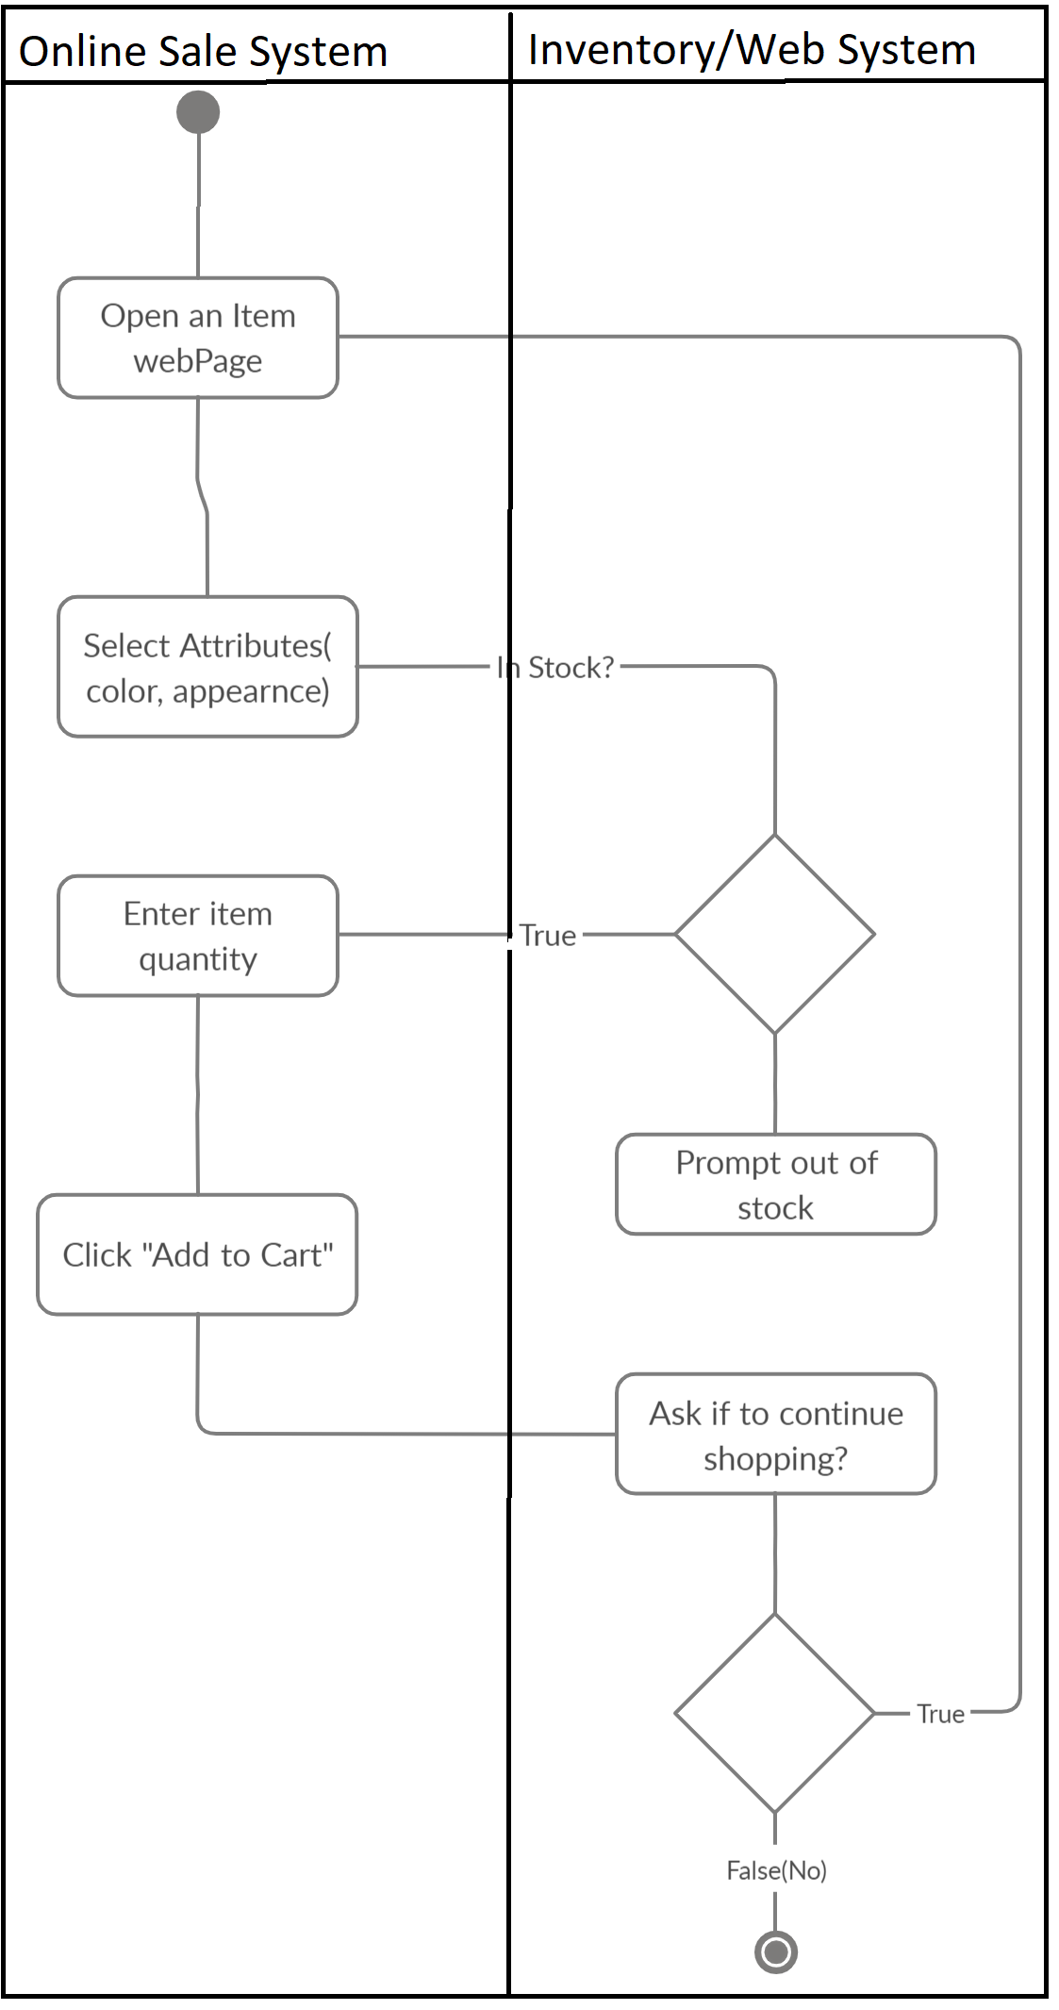

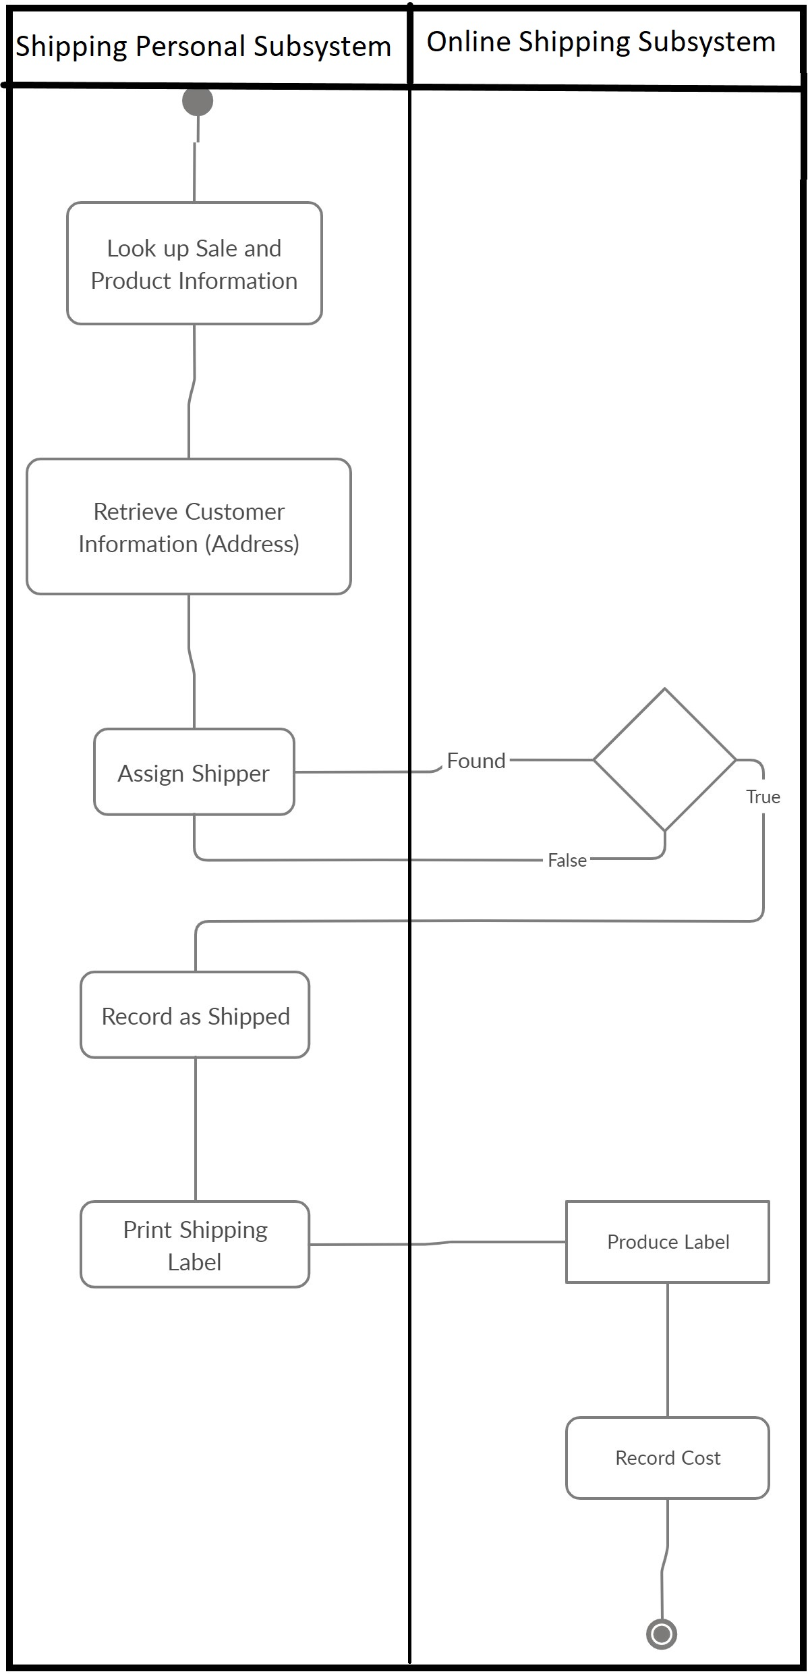

c)

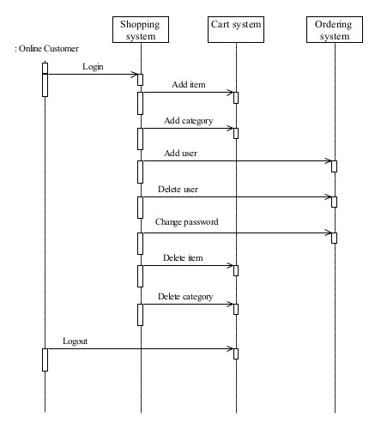

3.

a)

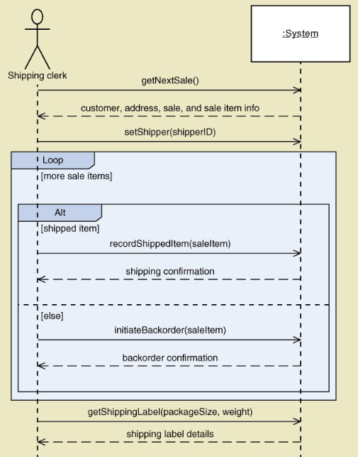

c)

4.

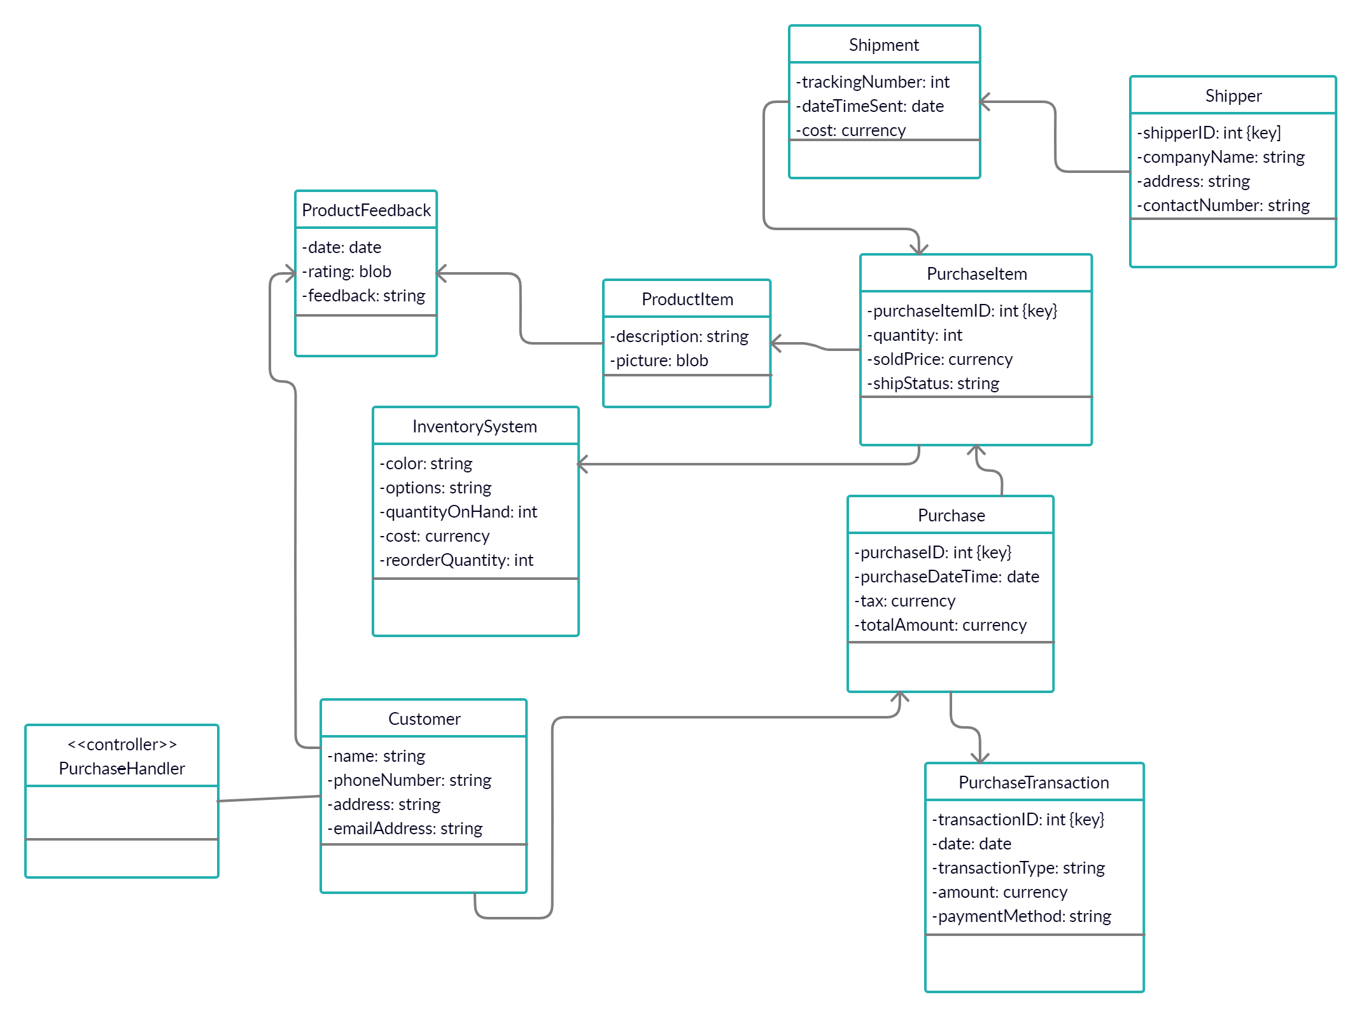

First Cut Design Class Diagram